Write a query identifying the *type* of each record in the **TRIANGLES** table using its three side lengths. Output one of the following statements for each record in the table:

* **Equilateral**: It's a triangle with  sides of equal length.
* **Isosceles**: It's a triangle with  sides of equal length.
* **Scalene**: It's a triangle with  sides of differing lengths.
* **Not A Triangle**: The given values of *A*, *B*, and *C* don't form a triangle.

**Input Format**

The **TRIANGLES** table is described as follows:

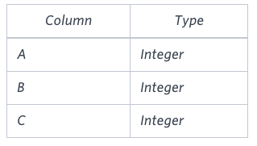

Each row in the table denotes the lengths of each of a triangle's three sides.

**Sample Input**

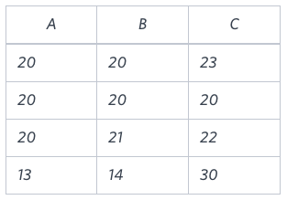

**Sample Output**

Isosceles

Equilateral

Scalene

Not A Triangle

**Explanation**

Values in the tuple  form an Isosceles triangle, because .  
Values in the tuple  form an Equilateral triangle, because . Values in the tuple  form a Scalene triangle, because .  
Values in the tuple  cannot form a triangle because the combined value of sides  and  is not larger than that of side .